School Resource
Binder

April 2024



Providing links to:

- School Nutrition Funding
- Healthy Living Funding
- Healthy Living Resources
- School Partners
- Support

School Nutrition Funding

Child Nutrition Council of Manitoba

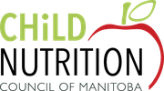
The Child Nutrition Council of Manitoba is a charitable organization dedicated to helping school children learn, grow, and succeed by supporting school meal and snack programs.

Website: http://childnutritioncouncil.com

Contact: Child Nutrition Council of Manitoba
191 Provencher Boulevard
Winnipeg, MB
R2H 0G4
Tel (voicemail): (204) 202-1233
info@childnutritioncouncil.com

PC Children’s Charity: Feeding hungry minds
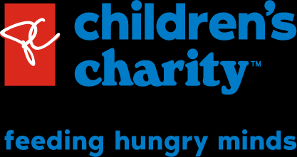
President’s Choice Children’s Charity is a national non-profit organization dedicated to remove hunger as a barrier for a happy life, and to educate children about food and nutrition. Programs offered are:
- Power Full Kids Eat Well Program Canada’s largest charitable school food program combines daily meals and snacks with fun activities and resources designed to empower children with the skills to grow and cook.

- Power Full Kids Equipment Fund: Schools can receive up to $2,000 annually for the purchase the equipment necessary to deliver daily school food programs.

- Power Full Kids Grow & Cook: Schools that participate in the Power Full Kids | Grow & Cook program can receive funding to cover the cost of tools for students or classroom equipment intended to help educators incorporate food-based education into their lesson plans.

- Power Full Kids | Future Growers projects link the production of food with the culture and traditions of the people who consume it - using technology as a powerful compliment to land-based food systems to overcome some of the impacts of isolation, climate change and colonial industrialization on Indigenous food sovereignty.

- President’s Choice Children’s Charity will award one school annually with a purpose-built container farm, installed on school property, to grow fresh produce and provide an alternate classroom.

Website: https://www.pcchildrenscharity.ca/

Contact: Ontario, Western & Atlantic
1 President’s Choice Circle
Brampton, ON
L6Y 5S5
PCCharity@Loblaw.ca

Breakfast Clubs of Canada

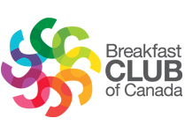

Breakfast Clubs of Canada (BCC) is a national not-for-profit organization dedicated to providing services and funding to school breakfast programs. BCC accepts applications year-round from schools, school boards, and community organizations seeking support for breakfast programs offered to school-aged children and youth during the school year.

Website: https://www.breakfastclubcanada.org

Contact: 135-G de Mortagne Blvd
Boucherville (QC) J4B 6G4

Phone: 450-641-3230
Phone Toll Free: 1-888-442-1217
Fax: 450-641-7841
info@breakfastclubcanada.org

Show Kids You Care


Show Kids You Care is an independent non-profit organization serving communities throughout Canada. They lead a national network of meal programs for kids living in poverty and other difficult situations in Canada. To apply for funding visit their website at https://www.skyc.ca/apply-for-funding/

Website: https://www.skyc.ca/

Contact: 15 Westney Road North
PO Box 31089
Ajax Ontario, L1T 3J5

Phone # toll free: 1-888-478-6528

The North West Company: The Healthy Horizons Foundation

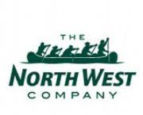

The Healthy Horizons Foundation is a non-profit charitable organization dedicated to the health and well-being of children and youth in Northern communties. They provide grants to community-based youth programs focused on physical activity, nutrition, education and well-being.

Grant applications are evaluated by the Healthy Horizons Foundation Board of Directors twice a year.

Website: https://www.northwest.ca/foundation/apply-for-funding/grant-application

Contact: C/O Healthy Horizons Foundation

77 Main Street

Winnipeg, MB

R3C 2R1

healthyhorizonsfoundation@northwest.ca

Healthy Schools Grant



The Healthy Schools Grant advances comprehensive school health by supporting projects that enhance health and wellness among school-aged children and youth to create sustainable healthy school communities. The Healthy Schools Grant enables school communities to infuse wellness into the culture of their schools by focusing on the priority health topics of Healthy Schools:
- healthy eating
- mental health
- physical activity
- safety and injury prevention
- sexual health
- substance abuse and addictions
The Healthy Schools Grant is available for all schools in Manitoba, including public, independent (funded and non-funded), institutional, and First Nations Schools. The funding formula is calculated as:
- Schools (Independent, and First Nations) - $125 base funding plus $2.06 per student
Website: https://www.gov.mb.ca/healthyschools/hsgrant/independentfn.html
Contact:
Phone: (204) 786-7345
Email: healthyschools@gov.mb.ca

Healthy Living
Funding

Healthy Together Now Community Funding

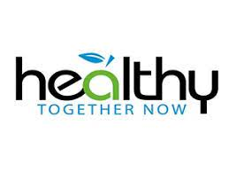

Healthy Together Now is a government-funded, community-led initiative to prevent chronic disease in Manitoba. Funding supports primary prevention activities in physical activity, healthy eating, tobacco prevention and reduction and mental well-being.

Application Guide: https://healthytogethernow.net/wp-content/uploads/2020/10/HTN_Funding_Guidelines_Eng2020.pdf

Wesbite: https://healthytogethernow.net/funding-guidelines/

Contact: htninfo@gov.mb.ca

Saputo Promoting Healthy Lifestyles Sponsorship



Saputo partners with organizations whose core mission is to inform, motivate and pursue initiatives that help communities adopt healthly lifestyles habits through proper nutrtion and physical activity. They offer sponsorships to non-profit organizations promoting healthy living initiatives.

Website: https://www.saputo.com/en/our-promise/community/our-partnerships/sponsorship-requests

True North Aid Community Grant Program



The True North Aid Community Grant program provides funding to support Indigenous-led projects in northern and remote communities in Canada that aim to create positive and impactful community-centred change. True North Aid will provide funding toward projects that empower communities with holistic and sustainable projects focused on, but not limited to:

- The advancement of education, cultural revitalization, and community-building
- Reclaiming plant/food sovereignty
- Addressing housing inequities
- The promotion of holistic physical, emotional, mental, and spiritual well-being
- Equitable access to essential resources

Website: https://truenorthaid.ca/community-grant-program/

Contact: P.O. Box 37023

Kitchener, ON N2A 4A7 ​

Phone: 1-226-444-3385

Email: info@truenorthaid.ca

Canada Post: Community Foundation

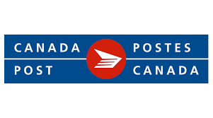

The Canada Post Community Foundation provides grants to Canadian Schools, charities and community organizations that make a difference in the lives of children and youth (up to age 21). They offer:

- Grants for community-based support projects valued at up to $25,000.00 each.
- Indigenous Truth and Reconciliation Signature Grant valued at $50,000.00

Website: https://www.canadapost-postescanada.ca/cpc/en/our-company/giving-back-to-our-communities/canada-post-community-foundation.page

TD Friends of the Environment Foundation Grant



The TD Friends of the Environment Foundation is a national charity that funds environmental projects across Canada. The Foundation supports a wide range of environmental initiatives, with a primary focus on environmental education and green space programs.

Eligible projects include schoolyard greening, park revitalization, community gardens, park programming and citizen science initiatives. Applications are reviewed twice each year and due January 15th or July 15th.

Website: https://www.td.com/ca/en/about-td/ready-commitment/funding/fef-grant/

Contact: tdfef@td.com

KidSport Canada

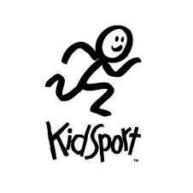

KidSport provides grants to help cover the costs of enrolment in sports so that all kids aged 18 and under in Manitoba can play a season of sport. KidSport grants provide financial assistance for registration fees.

If you want to apply for a KidSport grant or learn more about the program details, start by finding your closest chapter. KidSport Manitoba has five chapters across Manitoba: North, East, South, West and Winnipeg. More information can be found by visiting their website.

Website: https://kidsportcanada.ca/manitoba/provincial-fund/

Provincial Office:

KidSport Manitoba

145 Pacific Avenue

Winnipeg, MB

R3B 2Z6
Tel: 204-925-5911
Fax: 204-809-4659
Email: KidSportMB@sportmanitoba.ca

Healthy Living Resources

Manitoba Healthy Schools
Healthy Schools is Manitoba’s school health initiative designed to promote the physical, emotional and social health of school communities.

Their mission is to create school environments that enhance the healthy development of children and their families by working in partnership with community service providers. Their website has a number of resources for educators and schools related to healthy eating, physical activity, sexual health, mental health, safety and injury prevention and substance abuse and addictions.

Website: https://www.gov.mb.ca/healthyschools/

Contact: Healthy Schools
Phone: (204) 786-7345
Email: healthyschools@gov.mb.ca

Nüton



Nüton is a team of registered dietitians from Dairy Farmers of Manitoba that provides nutrition education resources and training for Manitoba educators. Their website contains great teaching resources that can be ordered at a minimal cost, some being free, as well as recipes, teacher resources, activities for kids and nutrition webinars. Nüton also offers training and educational workshops to school staff.

Website: https://nuton.ca/

Contact:
4055 Portage Avenue
Winnipeg, Manitoba
R3K 2E8

Phone: 204-488-6455
Email: Nuton@milk.mb.ca

Kids in the Kitchen Manual

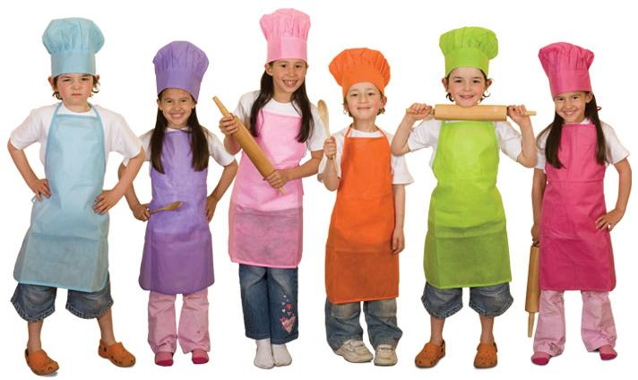

Offers instruction on how to start and run a cooking club for children ages 6-11. The manual includes steps for creating a Kids’ Cooking Club and sample forms and letters. The manual contains 32 recipes in both a facilitator format and reproducible handout for children to use at home. It also includes 34 activities for groups of children.
To download a copy of the manual: https://nuton.ca/site-files/KIK-Book-Final-s.pdf

Fit Kids Healthy Kids



Fit Kids Healthy Kids is a Physical Literacy program founded as a partnership between Doctors Manitoba and Sport Manitoba. It teaches children and their adult leaders the fundamentals of movement that make kids confident and competent in sport, recreation, and life.Their website has a number of lesson plans, games and acitivity cards to help keep kids fit and healthy.

Website: https://www.sportmanitoba.ca/fkhk/

Contact:
145 Pacific Avenue
Winnipeg, MB
R3B 2Z6
Phone: 204-925-5600
Email: fitkidshealthykids@sportmanitoba.ca

Diabetes Canada

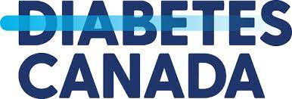

Supports people affected by diabetes by providing diabetes education, research, resources, service, and advocacy. The Diabetes Canada website a great online resource hub with information about diabetes. Diabetes Canada provides easy-to-understand information about living and eating well with diabetes, plus interactive tools educational webinars, recipes, events and more. Their website also includes Guidelines for the Care of Students Living with Diabetes at School: https://www.diabetes.ca/learn-about-diabetes/your-rights/kids-with-diabetes---education
Website: http://www.diabetes.ca/
Contact: 207-1 Wesley Avenue
Winnipeg, Manitoba
R3C 4C6

Phone: 204-925-3800
Fax: 204-949-0266

Moving Forward with School Nutrition Guidelines
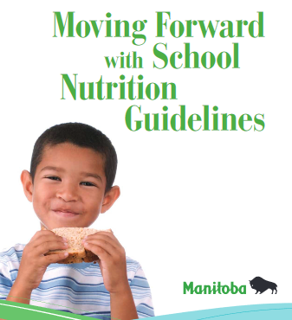
The Moving Forward with School Nutrition Guidelines has been developed to promote healthy eating and help students develop a healthy relationship with food. The guidelines are divided into six areas: School Environment, Breakfast, Snack, and Lunch Programs, Cafeteria, Canteen and Vending, Sporting Events, and Special Lunch Day.

The guidelines in this document apply to foods sold in, or provided by, schools in Manitoba. They are not intended to evaluate the food students bring into schools, although the nutrition information may be helpful to parents and communities.

Website to download the handbook: https://www.gov.mb.ca/healthyschools/foodinschools/documents/mfsng/mfsng.pdf
Canadian 24-Hour Movement Guidelines

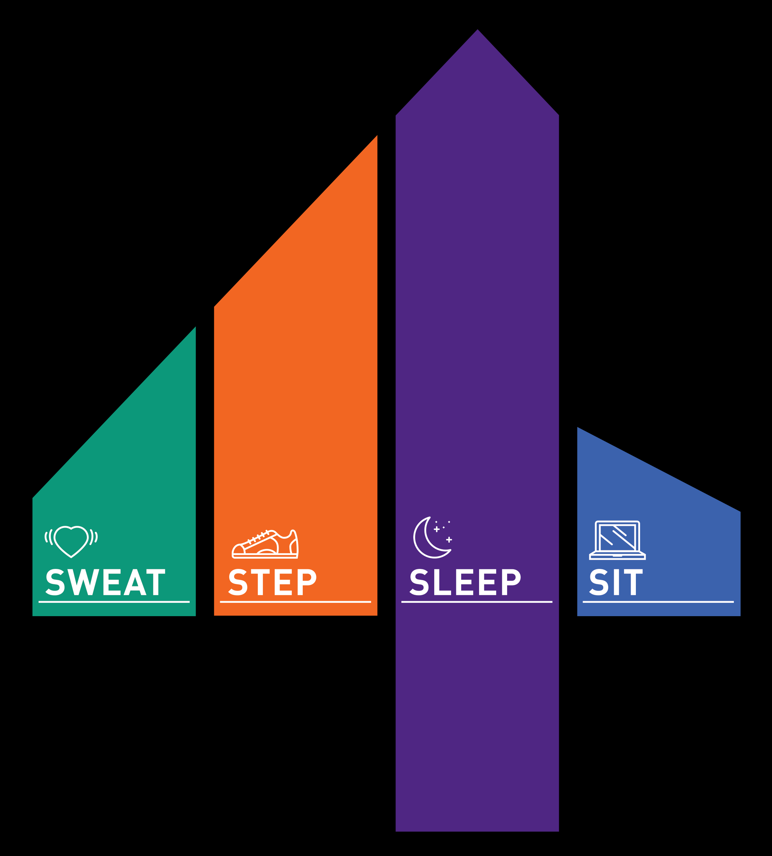

An Integration of Physical Activity, Sedentary Behaviour, and Sleep. The Canadian 24-hour movement guidelines provide recommendations on various types of physical activity woven together with guidance on sedentary and sleep behaviours for each age group.

To view or order copies of the Canadian Physical Activity Guidelines go to:

Website: www.csep.ca/guidelines

Winnipeg in Motion



Winnipeg in Motion’s site offers tips, tools and resources to add more physical activity to your day. It includes suggestions for at work, school and during play for people of all ages.

Website: https://www.winnipeginmotion.ca/index.php
Contact: getactive@winnipeginmotion.ca

Talk Tobacco



Talk Tobacco is a free confidential program offering culturally appropriate support and information about quitting smoking, vaping and commercial tobacco use to First Nations, Inuit, Métis and urban Indigenous communities.
Talk Tobacco provides free and confidential services offering culturally tailored support and information about quitting smoking or vaping designed with input and guidance from First Nation, Inuit, Métis and urban Indigenous leaders, partners, community members and health care providers.

Website: https://www.smokershelpline.ca/talktobacco/home
Phone: 1 833 998-TALK (8255)
Live Chat: see live chat pop-up box on their website: https://www.smokershelpline.ca/talktobacco/home
Text: CHANGE to 123456
Email: talktobacco@cancer.ca

The TEACH Project
​The Training Enhancement in Applied Counselling and Health (TEACH) Project is a tobacco cessation education program. TEACH provides continuing education and capacity-building focused on training healthcare providers to support their clients with tobacco addiction and cessation, and address e-cigarette use/vaping. Their website also includes resources, tools and tips for smoking cessation.
Website: https://www.nicotinedependenceclinic.com/en/teach
First Nations IT’S TIME Toolkit
The TEACH Project offers a First Nations-specific version of IT'S TIME - Indigenous Tools and Strategies on Tobacco: Interventions, Medicines and Education, which provides community workers, community members, and others with culturally-relevant commercial tobacco cessation tools. IT'S TIME is a model of collaboration and integration between mainstream cessation resources, and Indigenous ways of learning and knowing. This resource was developed in collaboration with an Engagement Circle of First Nations community workers, health care providers and Elders.
The toolkit includes:
- Helper's Guide: six 90 minute sessions of cognitive behavioural therapy incorporating Indigenous Ways of Knowing
- Helper's Condensed Guide: one page summaries of key activities to guide each of the six sessions
- Helper's Resources: background materials to support activities in the Helper's Guide
- Participant Booklet: handouts and worksheets corresponding to the content of each session
Link to the toolkit: https://www.nicotinedependenceclinic.com/en/teach/practitioner-resources/teach-tool2
The TEACH Project- Online Learning Environment
The TEACH Project’s online learning environment offers evidence-based, accredited, accessible, and clinically relevant information to enhance treatment capacity for tobacco cessation and health interventions.
Website: https://teach.camhx.ca/moodle/#courses
Health Canada- Youth Vaping Prevention


Health Canada’s website includes information for youth to learn about vaping and the risks associated. Their website includes interactive activities, videos and tips to navigate peer pressure.
Website: https://www.canada.ca/en/services/health/campaigns/vaping.html

Their website also includes resources to help raise awareness of the consequence of vaping for youth such as posters, handouts, awareness kits, videos and social media images to share about vaping.
Website: https://www.canada.ca/en/health-canada/services/smoking-tobacco/vaping/awareness-resources.html

Mental Wellness, Substance Use and Suicide Prevention Supports

Manitoba Non-Insured Health Benefits
Medical supplies and equipment, mental health counselling and vision care inquiries. For mental health counselling, you can request a current listing of approved mental health providers for your area in Manitoba.

Contact: 1-800-665-8507

Hope for Wellness Help Line
The Hope for Wellness Help Line offers immediate mental health counselling to all Indigenous peoples across Canada. They are available 24/7 by phone and online chat.

Contact: 1-855-242-3310
Website/online Chat: www.hopeforwellness.ca

988.ca
If you are feeling like you have lost hope and are struggling to cope, if you are dealing with thoughts of suicide, or if you are worried about someone else, they are there for you.

Call: 9-8-8
Text: 9-8-8
Website: https://988.ca/

The Centre for Suicide Prevention (CSP):
Centre of Suicide Prevention is an education centre. They offer online and print resources as well as interactive workshops to teach how to equip yourself to respond to a person considering suicide.
Website: www.suicideinfo.ca

School Partners

Manitoba First Nation Education Resource Centre (MFNERC)

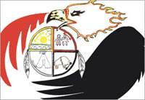

The MFNERC provides the province’s leading education, administration, technology, language and culture services to First Nations schools in Manitoba. Professional development training is also provided for school board members, administrators, teachers and teaching assistants. The MFNERC is committed to working in partnership with Manitoba First Nations to ensure the highest standards of education are achieved in First Nations schools.

Contact:

120-200 Alpine Way.
Headingley, MB
R4H 1C8

Phone: 204-594-4267

Fax: 204-831-1301

Winnipeg Toll Free: 1-866-319-4857

Thompson Toll Free: 1-877-506-1568

General inquiries: info@mfnerc.com

Website: https://mfnerc.org/

Frontier School Division

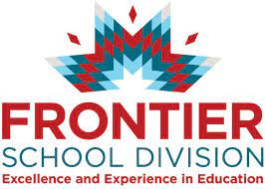

Frontier School Division is a part of a number of communities across the province including First Nation communities. The school division is committed to building and maintaining relationships across the diverse communities that comprise Frontier. Elected Chiefs and Councils, organizational leaders, and the Division work together as partners in the education of their students.

Contact:
30 Speers Rd
Winnipeg, MB
R2J 1L9

Phone: (204) 775-9741
Fax: (204) 775-9940
Email: Frontier@fsdnet.ca
Website : https://www.fsdnet.ca/

National Indigenous Diabetes Association Inc. (NIDA)

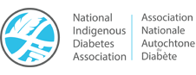
NIDA envisions diabetes-free healthy communities. NIDA is involved with, raising awareness about diabetes and Indigenous peoples, and promoting healthy lifestyles to prevent the onset or complications of diabetes for all Indigenous peoples.
NIDA has also hosted national conferences to raise awareness of diabetes among Indigenous People and share success stories. They have also partnered with other organizations in support of specific projects aimed at reducing diabetes-related complications.

Contact:
202-160 Provencher Blvd
Winnipeg, Manitoba
R2H 0G3
Canada
Telephone: (204) 927-1221
Fax: (204) 927-1221
Email: coordinator@nada.ca

Website: http://nada.ca/

Support

Food Matters Manitoba
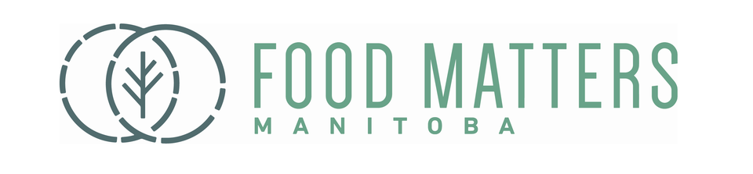

Food Matters Manitoba is a non-profit organization that envisions sustainable food systems rooted in food justice. Food Matters Manitoba offers:
- Community workshops
- Food Action Hub on their website includes a vast amount of resources and is a place to share one’s experience, knowledge and favourite food program resources with fellow community practitioners across Manitoba
- Northern & Community Partners Program supports food security initiatives. Activities include land based learning and community food production: snaring, skinning, drying, medicine gathering and processing, hunting, butchering, fishing & ice fishing, seed starting, gardening, composting, animal husbandry and cooking, canning & drying.

Contact:

422 Notre Dame Ave
Winnipeg, Manitoba
R3B 1R1
Phone: (204) 943-0822

Fax: (204) 943-0823

Toll Free: 1-800-731-2638
Email: info@foodmattersmanitoba.ca
Website: https://foodmattersmanitoba.ca/
Manitoba Health- Certified Food Handler Training Program

Food handler training is for all food service personnel who are responsible for the receiving, preparing and serving of food.
Website:https://www.gov.mb.ca/health/publichealth/environmentalhealth/protection/foodsafe.html

Contact:
Phone: (204)-945-3705
Toll Free: 1-855-236-1566
Email: foodsafe@gov.mb.ca

List of approved private contractors: https://www.gov.mb.ca/health/publichealth/environmentalhealth/protection/docs/contractorlist.pdf

Regional Food Security Coordinator

The Regional Food Security Coordinator acts as liaison for all 63 First Nations communities in Manitoba for food security information and supports through community visits, phone calls, emails, and through linking communities with other food security resources available to them. This position provides support and advice to communities and tribal councils in implementing the food security activities including starting and/or maintaining community gardens, raising chickens and assisting communities in establishing greenhouse projects, to name a few. If you are interested in starting up a food security project in your community and are unsure where to start feel free to connect with Karen Flett for assistance.

Contact: Karen Flett

Four Arrows Regional Health Authority
600 – 338 Broadway Avenue
Winnipeg, MB R3C 0T2

Phone: 204-947-2397 Ext 105
Fax: 204-982-3359
Email: kflett@fourarrowsrha.org

Website: www.fourarrowsrha.org

Province of Manitoba, Northern Healthy Foods Initiative

The Northern Healthy Foods Initiative’s (NHFI) vision is for people to define their own food systems to access healthy foods in northern Manitoba. Our goals are:

- to increase food security efforts at the community level
- to strengthen community-led development
NHFI supports local and regional projects that contribute to the development of culturally relevant, healthy food systems, while improving health and well-being. NHFI’s role is to increase access to food by working with communities and coordinating efforts aligned with the program's goals and objectives.
Contact Information:

Northern Healthy Foods Initiative
Manitoba Indigenous Reconciliation and Northern Relations
300-352 Donald St
Winnipeg, MB, R3B 3H8
Phone: 204-792-8557

Website: https://www.gov.mb.ca/inr/major-initiatives/nhfi/index.html

Service Delivery Model
Food security projects are being delivered in northern and remote communities by community-based organizations including:

- Bayline Regional Roundtable delivers activities along the Hudson Bay Rail line.
371 Flemming Dr. Box 108
Wabowden, MB ROB 1S0
Ph: 204-689-2598
Fax: 204-689-2355
Email: baylinerrt@outlook.com
Administrator: Carol Sanoffsky
Administrative Assistant: Donna Sanoffsky

- Northern Association of Communities Council delivers activities in the southern part of the NHFI boundary.
Unit 20, 395 Berry Street
Winnipeg, MB R3J 1N6
Ph: 204-947-2227
Fax: 204-947-9446
Executive Director: Linda Payeur
Project Coordinator: Trinette Konge

- Four Arrows Regional Health Authority delivers activities in the Island Lakes area.
500-338 Broadway
Winnipeg, MB R3C 0T2
Ph: 204-947-2397
Fax: 204-982-3359
Executive Director: Alex McDougall
Program Manager: Byron Beardy

- Food Matters Manitoba delivers activities in the northern part of the Province.
422 Notre Dame Avenue
Winnipeg, MB R3B 1R1
General Office: 204-943-0822
Fax: 204-943-0823
Executive Director: Rob Moquin
Program Coordinator: Demian Lawrenchuk

- Frontier School Division delivers activities in the Frontier School Division.
Leaf Rapids Education Centre
Box 670
Leaf Rapids, MB R0B 1W0
LR School: 204-473-2403
Fax: 204-473-8632
Program Coordinator: Brian Trewin

Northern Manitoba Food, Culture and Community Collaborative

The Northern Manitoba Food, Culture, and Community Collaborative (NMFCCC) is an innovative collaborative of northern community people, northern advisors, funders and organizations working together to foster healthier and stronger communities in Northern Manitoba, through improved access to healthy foods and the development of resilient local economies.

The collaborative can support a wide variety of food production areas, including greenhouse, gardens, poultry, beekeeping and traditional food projects. This program seeks to achieve food independence through sustainable community economic development around harvest, production and consumption of traditional food by implementing a country foods program. If your community has an idea for a project, feel free to reach out NMFCCC to see how your idea might fit with their funding opportunities.

Website: http://www.nmfccc.ca/

Contact:
Phone: 204-229-1929
Email: amanda.froese@makeway.org

Unit 300 - 245 McDermot Ave
Winnipeg, MB
R3B 0S8

